**Ideation Phase**

**Empathy Map Canvas**

|  |  |
| --- | --- |
| Date | 25 November 2025 |
| Team ID |  |
| Project Name | BookStore |
| Maximum Marks | 4 Marks |

# **Empathy Map – BookStore (For Two User Personas)**

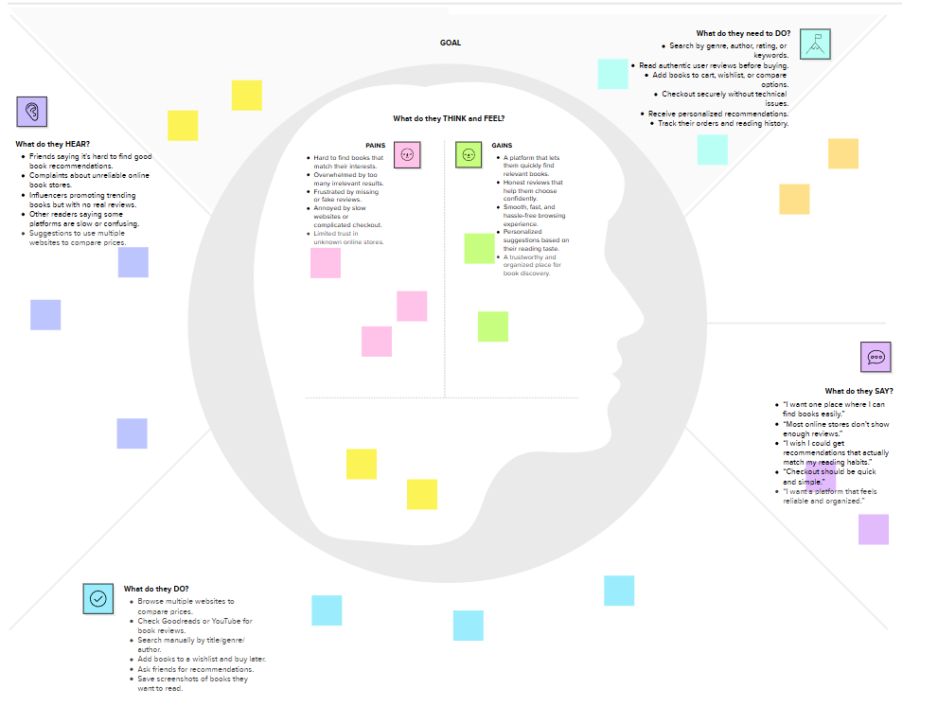

### Persona 1 – Bookstore Owner / Manager

**Says**

I need a simple system to manage books and inventory

I want to know which books are selling well

I want faster billing and better stock updates

**Thinks**

Manual stock updates take too much time

A system should prevent stockouts and overstocking

Better data can improve sales decisions

**Does**

Tracks inventory and updates stock

Manages sales, orders, and customer requests

Analyzes best-selling books and adds new arrivals

**Feels**

Stressed when inventory is inaccurate

Relieved when reports are automated

Confident when the system is organized

**Pains**

Missing stock and delayed updates

Slow billing and manual processes

Hard to identify fast-selling items

**Gains**

Centralized inventory management

Real-time stock tracking

Automated reports and faster checkout

### Persona 2 – Customer (Book Lover / Online Shopper)

**Says**

I want to find the book I need quickly

Checkout should be fast and simple

I need to know if a book is available

**Thinks**

Searching should be easy with clear categories

Reviews help in choosing the right book

I hope I don’t waste time on unavailable books

**Does**

Searches books by genre, author, or title

Checks availability and compares prices

Adds items to wishlist or buys online

**Feels**

Frustrated if searching is slow or confusing

Happy when recommendations match preferences

Satisfied with fast and problem-free checkout

**Pains**

Hard to know availability

Too many options without guidance

Long queues or slow checkout processes

**Gains**

Quick search results and stock status

Personalized book suggestions

Smooth shopping and easy payment